# This Professor’s ‘Amazing’ Trick Makes Quadratic Equations Easier

## Looking for the answers to *ax*² + *bx* + *c* = 0? A mathematician has rediscovered a technique that the ancient Babylonians used.

This alternate method for solving quadratic equations uses the fact that parabolas are symmetrical.

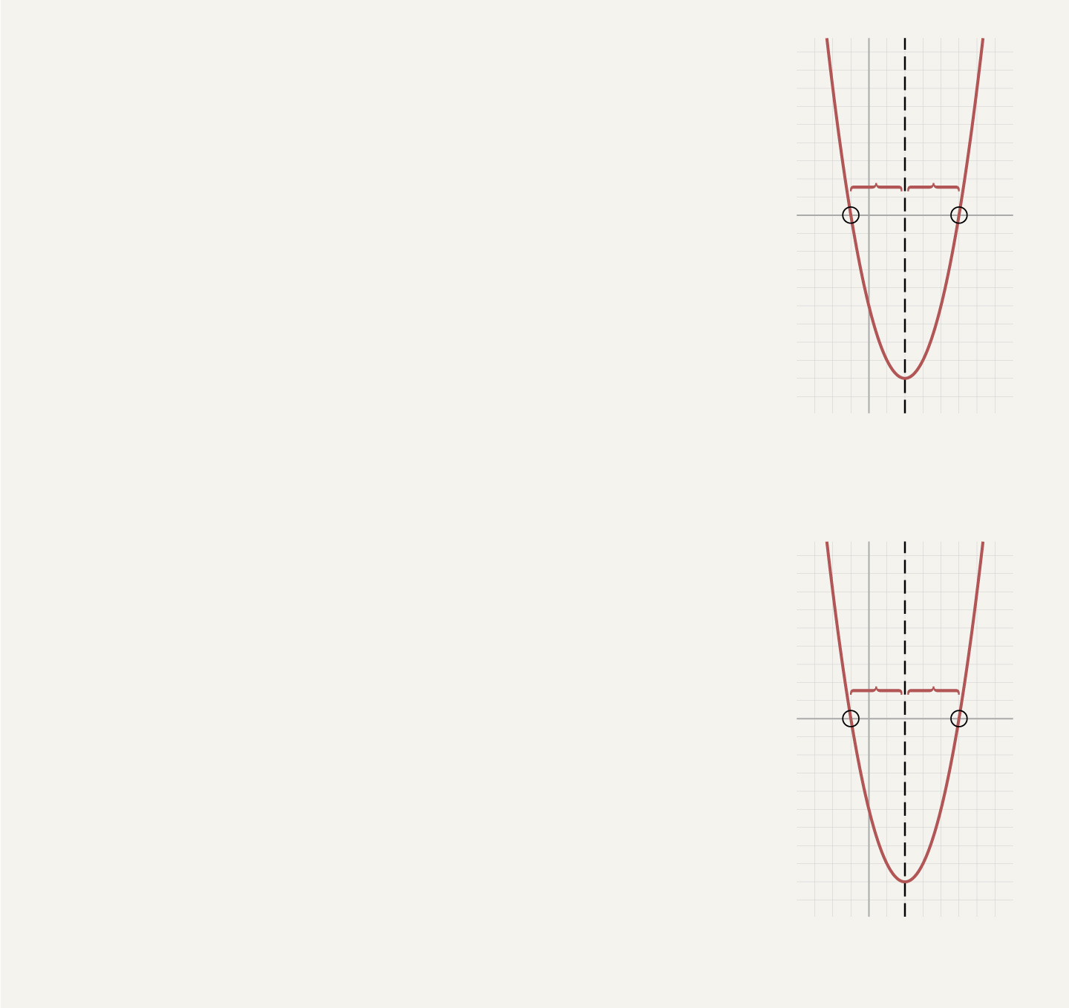

For example, in this parabola:

***y* = *x*2 – 4*x* – 5**

The two solutions when ***y* = 0** are the symmetrical points ***r*** and ***s***,  
where the parabola crosses the ***x***-axis.

The midpoint, or average, of ***r*** and ***s*** is the axis of symmetry of the parabola.  
We want ***r* + *s* = –*b***, which happens when the average of ***r*** and ***s*** is **–*b* ÷ 2**.  
In this example:

**4 ÷ 2 = 2**

The two solutions to the quadratic equation will be the axis of symmetry  
plus or minus an unknown amount, which we’ll call ***u***.  
In this example:

***r* = 2 – *u*** and ***s* = 2 + *u***

To find ***u***, we want the product of ***r*** and ***s*** to be equal to ***c***,  
which in this example is **–5**. Rewriting ***r*** and ***s*** in terms of ***u***:

***r* × *s* = –5**

**(2 – *u*) × (2 + *u*) = –5**

Solving that yields **22 – *u*2 = –5** or ***u*2 = 9**, so ***u* = ±3** works.

The two solutions to this quadratic equation are **2 – *u*** and **2 + *u***, or **–1** and **5**.  
In other words, this parabola intersects the ***x***-axis when ***x* = –1** and ***x* = 5**.

The same method also works for equations that are not readily factorable.

Dr. Loh’s method allows people to calculate the answers without remembering the exact formula. (It also provides a more straightforward proof.) “Math is not about memorizing formulas without meaning, but rather about learning how to reason logically through precise statements,” Dr. Loh said. Mr. Wong said Dr. Loh’s version is easier for students because it “provides one method for solving all kinds of quadratic equations.”